We thank the reviewers for their thoughtful, supportive and constructive suggestions. We have taken these comments on board to revise the paper, as detailed below. All page/line numbers refer to the tracked version of the manuscript.

Reviewer #1

This paper uses an ensemble of models to estimate the total number of (all-cause) deaths that would have occurred in the absence of the Covid-19 pandemic for 17 different countries. By comparing actual deaths to the model's predictions, the authors estimate the impact of the pandemic in each of these countries. The authors interpret their results in terms of demographic, temporal, and cross-national patterns. They argue that an advantage of this approach is that it allows for comparability between different countries.

I think this was an interesting and potentially important paper that has the potential to help the research community make sense of the impact of Covid-19 in a comparative way. The analysis is obviously timely, and it seems to be carefully done. My primary critique is that the analysis is entirely based on a complex ensemble of models, and, given this complexity, the Methods section is very short and lacking in detail.

We had described the models in a language that was accessible for a broad group of readers and had relied on citations to statistics sources for more technical materials. We now provide substantially more detail on the methods in the paper (PP. XX-XX, Lines XX-XX) as well as in the new Extended Data Table 5.

I have a few specific comments/questions:

- pg 5 - "posterior probability" - the conceptual definition provided here is helpful, but it would be more helpful if it was accompanied by information about exactly how this is calculated. Posterior probability of what? That (actual num deaths - ensemble predicted num deaths) > 0? One reason this is puzzling is that it seems to dichotomize the results into either an increase or a decrease - but it seems, intuitively, like there should be range of deaths that are within the normal amount of year to year variation -- ie, neither a meaningful increase nor a meaningful decrease. What seems to be of interest here is increases in deaths above the typical amount of year to year variation we'd expect to see in non-pandemic conditions.

As the Reviewer correctly states, in a probabilistic approach, there is a distribution of estimated excess deaths for each country and week, reported as credible intervals throughout the paper. This distribution then translates to posterior probability of an increase relative to a no-pandemic counterfactual, which is mirrored by a probability of a decrease, with the two summing to 100% – the balance of the two depends on where in counterfactual distribution the observed number of deaths falls. Where the entire range of excess deaths is positive, deaths have increased with a posterior probability ~100% and hence have decreased with a posterior probability of ~0%. Where the median estimate of excess deaths is zero, and the credible interval equally covers both positive and negative numbers, deaths have increased with a posterior probability of 50% (and hence decreased with a posterior probability of 50%). Elsewhere the posterior probability of an increase would be between 50% and 100% – for example 80% which also means a 20% posterior probability of a decrease. Therefore, there is no dichotomy of change but rather a probability for each, balanced with one for the other.

We have revised and expanded the explanation of posterior probability to clarify how it measures the variability/uncertainty in estimated excess deaths, and how the probability of an increase is balanced with one a decrease, and vice versa (P. XX, Lines XX-XX).

- pg 6 - it is surprising to learn that, in Italy and Spain, excess deaths fell short of deaths assigned to Covid-19. Though I see that this is not impossible, it would be interesting to hear more about why this might have happened

We have stated the potential explanations for both excess deaths being larger (P. XX, Lines XX-XX) and smaller (P. XX, Lines XX-XX) than Covid-assigned deaths. This heterogeneity itself supports consistent reporting of excess all-cause mortality using the approach that we have developed.

- pg 7 - in the discussion of the sex distribution of excess deaths, it is unclear to me whether or not the estimates here are adjusted for age (ie, the fact that, on average, more women survive to the oldest ages and the oldest ages have the highest risk of death to Covid-19). The discussion of over/under 65 results suggests that this finding could just be differences in exposure at the riskiest ages -- but over/under 65 is an extremeley coarse breakdown, so it's hard to say for sure. Does the interpretation that excess deaths among females are roughly equal to excess deaths among males adjust for differences in exposure by age?

We have not adjusted for age within each of our age bands for three reasons: First, countries release data on number of deaths for different age groups and those used here allowed us to have comparable ages across countries (for many, although not all, we could have used 0-44, 45-64 and 65+ years but in high-income countries deaths in young ages tend to be very low). Second, while absolute measures, e.g., number of excess deaths, may be affected by age structure, relative measures, i.e. percent increase in deaths, compare each group with itself under a no-pandemic scenario and hence are largely independent of age structure. As seen in Figure 5, relative increase is similar between men and women in older ages, where female longevity advantage is particularly pronounced in high-income countries. In contrast, in those aged younger than 65 years, there is a male disadvantage even though median age is virtually identical between men and women. Third and importantly, the policy interest is in the absolute burden of the pandemic. Therefore, the extent that the pandemic has a larger impact, either through direct infection or deaths from other diseases, in one sex or the other because they are older may be an explanation for a specific finding but one that should be maintained and influence policy choices that affect entire populations (this is contrast to clinical studies which t inform treatment for a specific patient taking into account their age). The combination of similar relative increase, and the policy interest in absolute burden, makes the near-disappearance of male mortality disadvantage seen in those with confirmed infections a novel and important finding of our study.

- my understanding is that the Methods section of the paper will be published online and, therefore, length is not a constraint. I would have found it helpful to see considerably more methodological detail. The authors write clearly about their methods, but there is a lot that is not described.

As stated earlier, we now provide substantially more detail on the methods in the paper (PP. XX-XX, Lines XX-XX) as well as in the new Extended Data Table 5. We would be happy to further expand specific components that would be useful for general as well as statistically-oriented readers.

- For example: I was not clear on how the strategy for making inferences from the ensemble of models accounted for model choice. Bayesian Model Averaging, which the authors cite, is based on combining models using some posterior estimates for the probability of each model. It is hard to tell from the description here, but that does not seem to be what the authors have done. It's OK, in my opinion, to adopt a different approach to analyzing their model ensemble - but I suggest describing what they did more precisely (and citing whatever it's based on).

We have done as suggested including citing relevant background work for the model averaging approach (PP. XX-XX, Lines XX-XX, Reference XX). We can also add a figure like the one below to graphically illustrate the approach if the Reviewer and Editors think it would help clarify the approach for general readers.

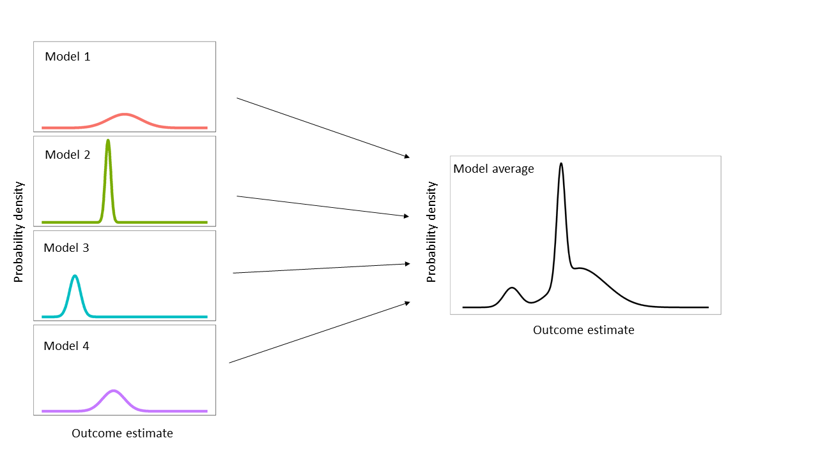
Reviewer #2
This is a very good paper that tackles a key issue in the measurement of the impact of COVID–19 on population health. Specifically, it uses data from vital registration in 17 countries to calculate the extent of excess mortality due to the pandemic. The paper is carefully done, and the methods address several key issues in the measurement of excess mortality, including accounting for long-term trends in mortality and model uncertainty. The findings pertaining to gender disparities are particularly interesting. The authors should be commended for this effort.

There are several aspects of the manuscript that - in my view - should be better explained or justified, or require revision.

First, the selection of countries to include. The authors exclude countries with <4M inhabitants without any justification. Why is that the case?

We have stated the reason – having many weeks with zero deaths which leads to at best such large uncertainty that would make it hard to differentiate between those places with and without an impact and at worse unstable estimates because the model – in the revised paper (P. XX, Lines XX-XX). For example, the number of deaths in 70% of weeks for women younger than 65 years in Liechtenstein was zero.

The authors also exclude several countries like Germany, the USA, Japan etc... due to unavailability of data. However, data for these countries, including weeks beyond the end of May, are available via the STMF data series of the Human Mortality Database. This is a major limitation of this paper, as it excludes countries that have taken very different paths in their epidemic and response. I encourage the authors to include these additional data series.

Germany, South Korea, Taiwan, Japan, Greece and the USA are all very interesting countries but despite having searched and reached out to relevant statistical/health agencies, we could not obtain data as we needed. Data from Japan, South Korea and Taiwan will be release next year. For Germany and USA, the data release by the national statistical offices are not divided by sex. The Human Mortality Database provides age-specific number of deaths but they split the data by sex themselves, based on pre-pandemic relationships, rather than obtaining sex-specific data from vital statistics, as indicated in the data file (https://www.mortality.org/Public/STMF/Outputs/stmf.xlsx). Given that we compare excess deaths in relation to both age group and sex, we did not want to use data that had carried forward specific age-sex patterns from pre-pandemic period. If this is an overcautious approach, we would be happy to include these countries but highlight this issue (e.g. as a footnote to relevant figures and tables).

Second, I do not find the term "first phase" particularly descriptive/useful in the title and in the rest of the manuscript. What does this refer to, epidemiologically? in terms of policies? Some large swaths of the countries under study have barely registered any spread of SARS-CoV-2 during the months under investigation (e.g., southwest France). In terms of lockdowns, there is also tremendous heterogeneity between countries, with some countries (e.g., UK) still in lockdown at the end of May. Why not explicitly state the dates under study in the title, rather than use this vague term of "first phase"?

This comment indeed mirrors our own deliberations and difficulty in choosing a phrase that was both short and described the analysis period. We avoided “first wave” because there is no agreement on when we move from first to second wave. We selected first phase on the premise that by the end of May, excess deaths in virtually all countries in our analysis was no longer distinguishable from zero – hence a new baseline. We of course specify the analysis period throughout the paper. If this reason is not convincing, we would be happy to use alternative wording, e.g., “early months”.

Third, it would be great to see how the estimates of excess mortality produced by each national statistical office compare with the modeled estimates reported here. Ideally, this would be added to the graphs in figure 2. At least some statistical offices (e.g., ONS, INSEE/INED etc...) have reported such estimates. That would help assess the impact of the modeling exercise on measurements of excess mortality.

Where available, the calculations by national statistical offices (which often rely on using the average of the past five years as their baseline) differ in terms of start week, duration and whether they report by sex or not. Therefore, any comparison would be affected by factors other than methodology. We have nonetheless added a short text that provides basic comparisons, while emphasising these differences.

Fourth, the authors treat changes in temperature as completely exogenous in their model(s), i.e., not affected by the COVID–19 pandemic. However, there have been many reports of reduced pollution levels during lockdowns and periods of reduced economic activity. That assumption should be better justified in my opinion.

As the reviewer correctly points out, there have been studies on how lockdown has changed levels of air and noise pollution but to our knowledge there is no evidence that lockdown has affected temperature in any measurable way. In fact, the only study we could identify, had estimated a short-term impact ~0.01°C,[Forster, 2020 #5691] which is orders of magnitude smaller than seasonal and interannual variation. Emphasising that temperature only appears in one half of the models in the ensemble, we would be happy to drop the corresponding models if there is other evidence that lockdown has had a detectable impact on temperature.

Fifth, on page 6, in considering the difference between deaths counted as COVID–19 and excess deaths, the authors do not consider the role of declines in other causes of deaths (e.g., accidents, homicides). Changes in the risk of dying from such causes, e.g., during lockdowns, might affect the comparison of "official" COVID–19 death counts and excess mortality in more complex ways than discussed in the paragraph.

This is correct and is now reflected, together with citations, in the text added following a related comment by Reviewer #1 (P. XX, Lines XX-XX).

Finally, I find that paper is weakest on page 12, when it discusses "the simplest lesson" of differences in excess mortality across countries. On the one hand, it is not in ideal position to draw lessons, because several countries with very important/exemplary epidemic paths were excluded (Japan, Korea, Germany, USA). On the other hand, it greatly simplifies the causal pathways between interventions such as lockdowns and excess mortality. These include complex interactions with competing risks etc... and require more extensive modeling. I suggest reformulating this paragraph to appear less confident/definitive.

We have modified this paragraph as appropriately and thoughtfully suggested (PP. XX-XX, Lines XX-XX).

Minor point:

in extended data table 1, please do not use "-" to connect the lower and upper bounds of a CI, especially when some lower bounds are negative. This is confusing. Maybe use "to" or a ";" instead?

We have done as appropriately suggested.

Reviewer #3
The authors present a compelling analysis of total and COVID-19 specific mortality from mid-February to end of May 2020. They estimate the counterfactual mortality for 17 countries (16 European plus New Zealand) as if there were no COVID pandemic through an ensemble of 16 Bayesian mortality projections that account for various factors including seasonality, temperature and short- and long-term mortality trends. They find almost 75% of excess mortality in these 17 countries, occurred in England and Wales, Italy and Spain, with little difference according to sex. They also find large heterogeneity in the magnitude of excess mortality across the countries able to be included with no or little detectable excess mortality in countries such as NZ, Bulgaria and Norway and with Belgium, Italy, Scotland, Spain and England and Wales comprising a group that carried the vast majority of the excess mortality burden.

1. This is an excellent paper that is based on sophisticated methods using the best available data. It is very clearly written. My only suggestion for better reader clarity is that the text describing Figs 2 and 3 is hard to align with the figures. Make clear panels A and B and perhaps some indicative text to walk readers through how to interpret the figures which are quite complex. The shading of probabilities in panel B is hard to follow so perhaps choose a country and walk the reader through how to read these figures.

A fair comment that we have implemented in the figure caption (P. XX, Lines XX-XX). We would be happy to further clarify as needed.

2. There is an intelligent and thoughtful discussion of what might explain the heterogeneity of excess mortality in this period using the Dahlgren/Whitehead framework of what drives population health but these factors seem unable to explain the divergent patterns across countries. We are left with trying to understand how the speed and severity of lockdowns and health system preparedness generated these divergent excess mortality trends.

We are pleased that the reviewer agrees with our use of this framework, which we found helpful in structuring our discussion. This thoughtful comment also reflects how challenging it was to write the discussion of our findings in a way that provides an all-embracing explanation. How an extreme event, affect deaths involves complex interactions of long- and short-term policies and actions. For example, being a communicable disease, strict lockdown inevitably interrupts community transmission although transmission in specific settings, e.g., care homes, hospitals and some work environments, can continue. At the same time, extensive (and at the extreme universal) testing, and effective contact tracing and isolation of cases and their contacts can minimise transmission even without lockdown.[Peto, 2020 #5692] In the submitted version of the paper, we had discussed these determinants, referring to countries where they were particularly relevant. As suggested by this comment, the revised closing paragraph now explicitly states some of the crucial determinants and their interplay (P. XX, Lines XX-XX). We have also added a new table (Extended Data Table 5) that provides information on population, response and health system determinants of excess deaths for all countries in the analysis so that interested readers can make additional comparisons. Finally, we have emphasised the complexity of these interactions, and the need for data and research to understand and address the pathways to impact in each country, in the strengths and limitations section (P. XX, Lines XX-XX).

3. In that regard, over 90% of the excess mortality is over age 65 and there has been much speculation in several countries about the ‘social, economic and geographic’ distribution of aged care, especially in regard to its privatization, and the role of specialist aged care facilities in point outbreaks. This is mentioned briefly but may deserve some more comment, if only as an area that might be explored if relevant data were available.

We have expanded this discussion as correctly suggested (P. XX, Lines XX-XX).

Editors comments

Editorially, we do not have much to add over the reviewer comments other than some formatting points. However, we would like for you to include (and cite in the main text) a Policy Summary. Briefly, this should have 3 parts: Background, Main findings and Limitations, and Policy Implications. This should preferably be cited in the Introduction and labelled Table 1. It will not count toward your non-text display item allocation.

We have added a Policy Summary following this formatting guidance (P. X, Lines XX-XX).

We also note that you have included your limitations in the Methods, this section should be moved to the Discussion as methods are online only. You may have up to 4000 words of main text (currently around 3200).

We have done so (P. X, Lines XX-XX).

Please reduce your Abstract to no more than 200 words (currently over 500).

We have reduced to 210 words (PP. X-X, Lines XX-XX). If necessary, we can find an additional 10 to shorten further.

Please can you reformat your references so that those cited in the main text are directly below the main text? Additional references that are cited only in the Methods should be listed below the Methods and numbered contiguously with those in the main text.

We have done so (PP. X-X, Lines XX-XX).

Additional revisions

Four other countries, namely Australia, Czechia, Poland and Slovakia, have now released sufficient data to meet our inclusion criteria and have been included in the analysis.

References

